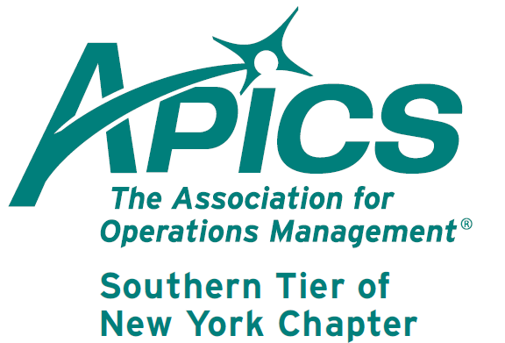
www.stapics.org

Member appreciation night with the Binghamton Mets!
Watch the B-Mets take on the Erie SeaWolves (Tigers)! Game time 7:05, but we'll need you to meet by 6:45. Cost to members: $5 (instead of $9). Includes discounted food vouchers: $3 (instead of $4.75) for small hot dog & soda. We'll need to receive payment by 6/19.

Yes, you can bring significant others & offspring for the same price provided someone is an APICS member!

Send checks with a list of who’s attending to:
Lee Schechter
905 Taylor Dr.
Vestal, NY 13850

Checks MUST BE received by the 6/19 mail delivery. Direct questions to: lschechter@stny.rr.com

APICS Update from Don Sheldon, Director of Education

CPIM – Basics of Supply Chain Management Training – We are in partnership with Broome Community College again to offer a CPIM series on their campus starting in June this summer. The fee is $685 per student for non-APICS members (includes a membership) or $485 APICS for members per module with the first offering being Basics of Supply Chain Management. Contact Broome Community College to register. Registration for the summer classes began May 06. Registration can be done by calling 607-778-5012. The fax number is 778-5535 and the class code is for the APICS CPIM course TC237.

The dates for this BCC Offering are:
28 June 1-5 PM Lessons 1&2
12 July 1-5 PM Lessons 3&4
26 July 1-5 PM Lessons 5&6
9 August 1-5 PM Lessons 7&8
23 August 1-5 PM Lessons 9&10

There will be a minimum class size to run the course. It is our intention to continue on through the CPIM series if there is interest.

If you are interested in any other Southern Tier offerings, please contact me at dsheldon@sheldoninc.com. Thanks!

Don Sheldon


We’re on !!!
Come and visit, poke around, or comment on us! Our name there is “Southern Tier APICS”. It’s just another way
for us to keep in touch with our membership.

Board of Directors 2012-2013

President Director of Publicity
Dave Gardner, CPIM Kelly Norieka
dave@protofab25.com Kelly.norieka@lmco.com

Executive VP /Director of Finance Director of Education
Steve Whited Don Sheldon, CPIM, CIRM, CSCP
steven.whited@acco.com dsheldon@sheldoninc.com

Secretary Director at Large
Debbie Unkel, CPIM Steve Stanchak, CPIM
deb.unkel@raymondcorp.com steve.stanchak@infoprint.com

Director of Membership/Director of Chapter Standards/

Director of Online Publication Director of Student Relations
Lee Schechter , CPIM Brian Arrnold
lschechter@stny.rr.com barnold@amphenol-aao.com

Director of Programming and Marketing Director of Communications
Michael LoSapio April McWeeney, CPIM
Michael.LoSapio@SynergyResources.net april.mcweeney@acco.com

Southern Tier APICS
PO Box 1107
Binghamton NY 13902-1107

